# The Fundamentals Of Code

1. Hello World
2. Code structure
3. The modern mode, “use strict”
4. Variables
5. Data Types
6. Interaction, alert, prompt, Confirm
7. Type Conversions
8. Basic operators, maths
9. Conditional branching: if; ?
10. Logical operators
11. Nullish coalescing operator ‘??’
12. Loops: while and for
13. Comparisons
14. The “switch” statement
15. Functions
16. Arrow Functions, the basics
17. Javascript specials
18. Function Expressions

# **Starting Code With Alerts And Prompts**

Alerts can be written like this. Alert(“hello”);.

If You would like to write temporary files we can you chrome console.

Or You can use the snippets editor.

For more deets check mdn docs

Alert[function]

(“Hello”)[message]

;[end]

An Window.alert() is a method which displays an alert dialog with the optional specified content and an OK button. Window.alert(message);

PARAMETERS

Message: A string you want to display in the alert dialog, or, alternatively, an object that is converted into a string and displayed.

EXAMPLE

Window.alert(“Hello World”);

Result

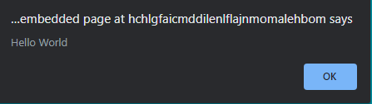

The alert Dialog should be use for messages which do not require any response on the part of the user, other than the acknowledgement of the message.

These prevent the user from accessing the rest of the programs interface until the dialog box is closed.